|  |  |
| --- | --- |
| **Name:- Aryan Dilipbhai Langhanoja** | **Roll Number:- 92200133030** |
| **Subject Name and Code:-** Foundation Skills On Sensor Interfacing (01CT1103) | **Date of Experiment:- 11-11-2022** |

|  |  |
| --- | --- |
| Task:- |  |

Switch case

|  |  |
| --- | --- |
| Components: |  |

* Arduino Uno R3
* LED
* Jumper Wires (Male To Male)
* Bread Board
* Laptop Or PC

|  |  |
| --- | --- |
| About the Project:- |  |

* In thisproject, we are going to use Arduino to blink the LED. In this, we use Switch Case. First we will take 6 LEDs.in that we will define A=2,B=3,C=4,D=5,E=6,F=7.After that, we will enter Value on serial Monitor, According to that, Led will blink.

|  |  |
| --- | --- |
| Output (you circuit implementation):- |  |

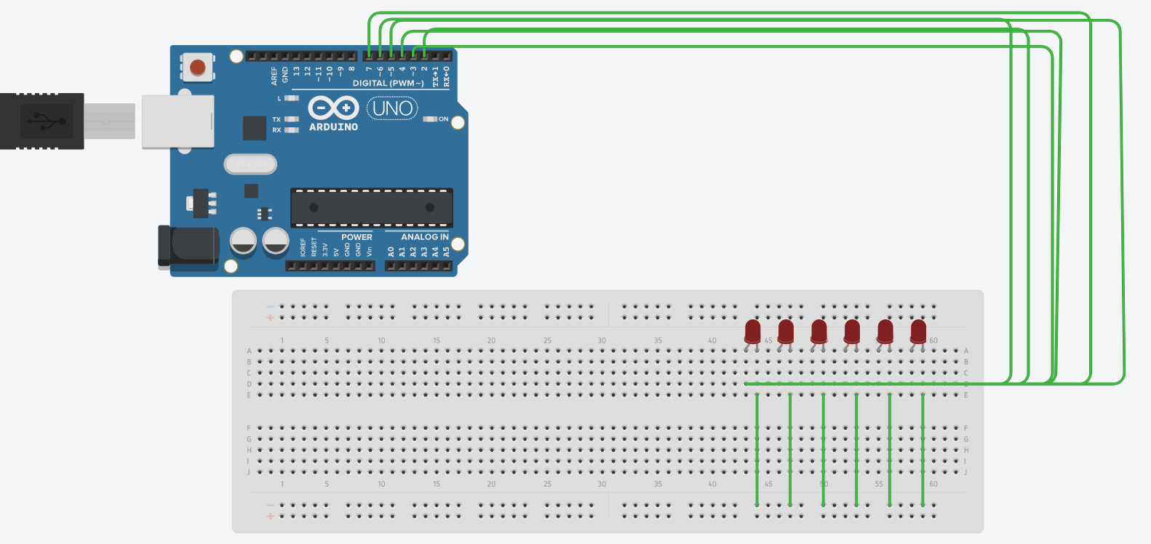

|  |  |  |
| --- | --- | --- |
| Schematic:- |  |  |

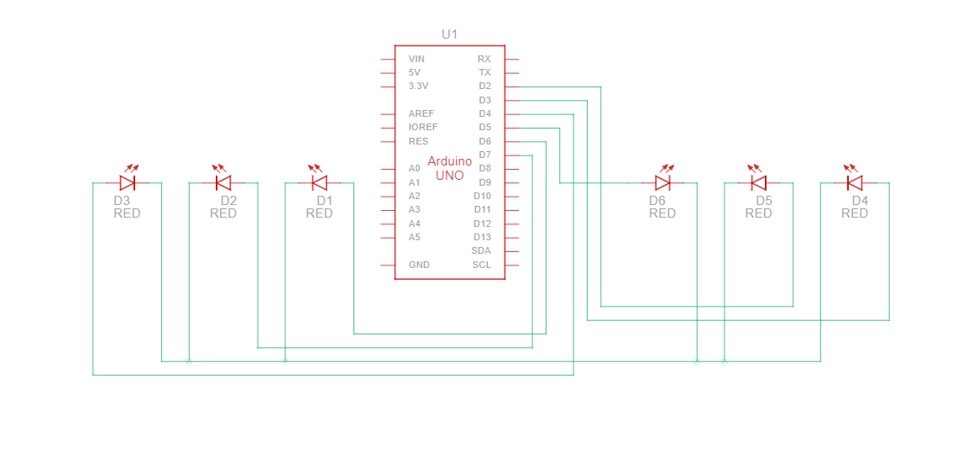

|  |  |
| --- | --- |
| Code:- |  |





|  |  |
| --- | --- |
| Conclusion:- |  |

* In This Experiment, We Learnt That How To Blink LED With Arduino with the help of switch case.